Types of Blobs
→ click on the upload option
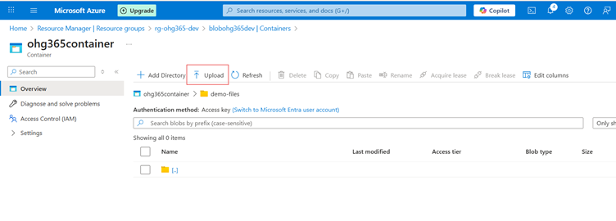

After clicking the Upload option, the Browse for Files panel will appear. Below that, the Advanced dropdown option will be visible. Click on Advanced.

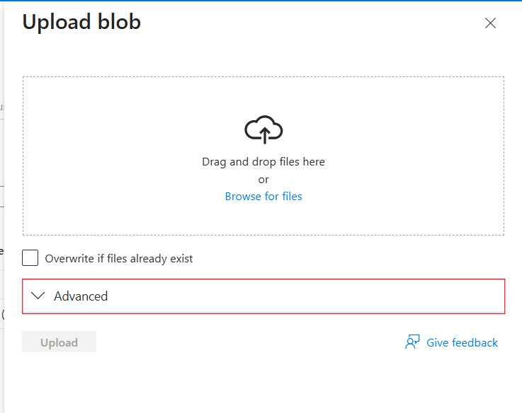

After clicking the Advanced option, the Blob Types will be displayed. Here, select the blob type you want.
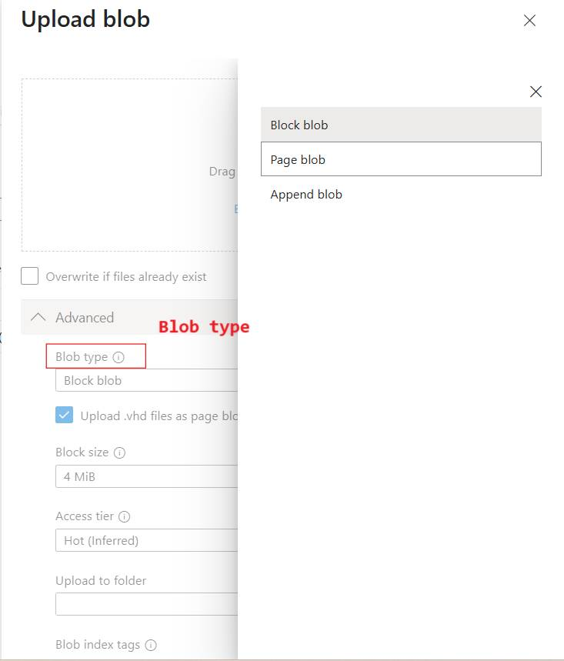

After selecting the blob type, all items in the folder will be displayed in the Overview page.
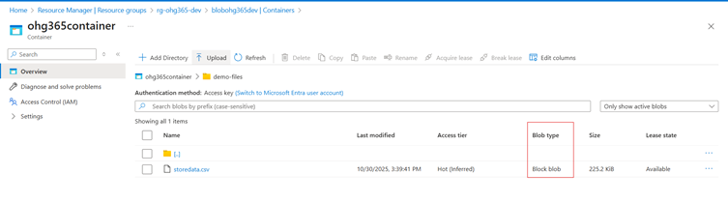

Blob Type | Best For | Example Use
Block Blob | Storing text or binary data | Images, videos, documents, CSVs
Append Blob | Data that is constantly appended (append-only) | Logs, telemetry, audit data
Page Blob | Random read/write access | Virtual machine disks (VHD files)

1. Block Blob
Most common blob type used in Azure.
What it is:
- Stores text and binary data (files like .txt, .jpg, .mp4, .csv, etc.)
- Data is split into blocks, and each block is identified by a block ID.
- You can upload or update blocks individually and commit them together.
✅ Use Cases:
- Storing images, videos, PDFs, and backups.
- Data files for analytics (CSV, JSON, Parquet).
- Large files uploaded in chunks.
Example:
You upload a 500 MB video file — Azure divides it into smaller blocks and uploads each part separately for speed and reliability.

2. Append Blob
Special type of blob for data that grows over time.
What it is:
- Optimized for append operations — you can only add new data to the end, not modify or delete existing data.
- Each time you add new information, it’s appended to the blob.
✅ Use Cases:
- Storing log files.
- Application telemetry or diagnostics data.
- Streaming data that’s constantly being added.
Example:
You’re logging website visits. Each time a new visitor arrives, their data (timestamp, IP, etc.) is appended to the existing log file.

3. Page Blob
Designed for random read/write operations.
What it is:
- Data is stored in fixed-size 512-byte pages.
- Allows fast read and write access to specific parts of the blob.
- Commonly used for storing Virtual Hard Disk (VHD) files that power Azure Virtual Machines.
✅ Use Cases:
- Storing Azure VM disks (OS and data disks).
- Large databases that require random access.
- Any workload that reads/writes frequently to specific sections of a file.
Example:
When you start an Azure Virtual Machine, its disk (a .vhd file) is stored as a Page Blob, allowing the VM to quickly read or write data anywhere on the disk.

Blob Type | Structure | Read/Write Behavior | Common Use
Block Blob | Data stored  as blocks | Upload or replace blocks | Files, media, documents
Append Blob | Sequentially added blocks | Append-only | Logs, telemetry, streaming data
Page Blob | Fixed 512-byte pages | Random read/write | Virtual machine disks, large databases

